Chen Zhong-Ao Zhuang

Kirby Index Score: .724, VRA Percentile: 93%, HRA Percentile: 75%

Notes: Elite Level Kirby Score due to elite Vertical Release Angle. Doesn’t miss below the strike zone with the FB, Keeps the ball in line with the plate really well with a great vertical release score.One bad outlier that can be seen on the chart and on video that hurts his overall score and horizontal release score. Has nine distinct clusters of pitches and can throw his fastball to any part of the zone.

Video Examples of the different clusters:

[Good Top of Zone](https://sporty-clips.mlb.com/b86af16d-cf51-4077-9f92-93731243114e.mp4)

[Middle-Middle](https://sporty-clips.mlb.com/14199e5f-1685-4e6f-b0dc-375024056585.mp4)

[Middle Armside](https://sporty-clips.mlb.com/263255db-8fbd-4c1c-a394-67d9ed6f6dfd.mp4)

[High Armside](https://sporty-clips.mlb.com/263255db-8fbd-4c1c-a394-67d9ed6f6dfd.mp4)

[Lower Third](https://sporty-clips.mlb.com/2e667e28-b355-43fd-8d9d-76d84b6ba1f8.mp4)

[Gloveside Down](https://sporty-clips.mlb.com/2e667e28-b355-43fd-8d9d-76d84b6ba1f8.mp4)

[Gloveside Middle](https://sporty-clips.mlb.com/d076ff2d-fad6-4862-ae4b-7fe36303a2cf.mp4)

[Gloveside High](https://sporty-clips.mlb.com/MVk3TDJfV0ZRVkV3dEdEUT09X1ZBWlZBVk5XVndVQUNWTUZVd0FBQ1FaWEFBTlhWUUlBQndjR1UxWUdBZ1JkQndOZg==.mp4)

[In-Line Above the Zone](https://sporty-clips.mlb.com/f4949901-19fe-4498-99fd-1f7b8ff33a15.mp4)

[Bad Outlier](https://sporty-clips.mlb.com/687bb697-ba19-48de-92c4-ead094e6cbfd.mp4)

Steven Echavarria

Four Seam FB Kirby Index Score: .442, VRA Percentile: 25%, HRA Percentile: 55%

Sinker Kirby Index Score: .302, VRA Percentile: 11%, HRA Percentile: 37%

Notes: Middle tier Four-Seam Kirby Score due to poor Horizontal Release Angles, Sprays the 4Seam and can’t keep it in line with the plate, Struggles to get to the top part of the strike zone and misses down too much for a 4Seam. 5 Clusters that are all pretty wide demonstrating a struggle to repeat throwing to certain tunnels. No Armside and down cluster

Sinker Kirby Score is very poor due to a real inability to land it to the glove side and in the top of the zone. Lots of bad armside high misses which are either mechanically driven or target driven Still struggling to land Right on Left Front Knee Sinker. 5 Clusters with really only one of them consistently in the strike zone. Can shifting his sinker target further to his glove side produce more strikes or is this a mechanical issue that can be worked on with the coaching staff?

Improving command for both pitches should definitely be a priority, in the long run, is there one that tunnels better and profiles better with his slider?

Video Examples of the different clusters:

Fastballs:

[In Line Middle of the Zone and Below](https://sporty-clips.mlb.com/dzdReHFfV0ZRVkV3dEdEUT09X0FWQllVZ2NCVlFJQURRQlJYZ0FBQ0FFRkFGaFRVbGNBQlFRQ0NRQUVCQU5RVWxRRg==.mp4)

[Gloveside lower half](https://sporty-clips.mlb.com/WGdSTk5fV0ZRVkV3dEdEUT09X1ZGQUhWVlVOWGxBQVdsWUJWUUFBQVZBQUFBTUdBUUFBQXdRQUJBVlhBZ0pSVmxkWA==.mp4)

[Gloveside upper half](https://sporty-clips.mlb.com/ae4fc83a-5821-4a0a-a92c-24c6bdd9fe8d.mp4)

[In Line Top of the Zone and above](https://sporty-clips.mlb.com/84bef699-e269-489d-992f-7c4b66bc255a.mp4)

[All Armside, corner to well off the plate](https://sporty-clips.mlb.com/a28911c8-11ac-4b59-b165-b3b03a57df48.mp4)

Sinkers:

[Armside High Misses](https://sporty-clips.mlb.com/41369eaf-1edd-44ea-bdaa-a0d3f4dda5d7.mp4)

[Armside Middle Misses](https://sporty-clips.mlb.com/ba75ce22-9aa9-41be-a12d-c30a8d9556b1.mp4)

[Armside bottom of the zone and below](https://sporty-clips.mlb.com/6bd52f58-0b9c-4619-998a-90af3c5763c6.mp4)

[Outer half in zone](https://sporty-clips.mlb.com/2f161bfe-96ca-4bd1-82b0-e5fe135f8be3.mp4)

[Gloveside bottom of the zone and below](https://sporty-clips.mlb.com/WGdSTk5fV0ZRVkV3dEdEUT09X1ZBWldBQVpWVkFvQVhGb0JBQUFBVUFkZkFBQlJVUUlBQ2xNQkFWWUZDUUZRVmdZSA==.mp4)

Blake Beers

Notes: FB Kirby Score is .270, currently 55 out of 64 in org, he is surrounded by Boyle, Jackson, Salinas just above him, Dicochea, De La Rosa just below him

Sinker Kirby Score is .267, 23 out of 29, Guante and Echavarria are about the same here. In general both pitches are very similar, 8 or 9 clusters for both with the same kind of pattern, big clumps of bad misses armside high and gloveside low, in general not particularly high on his command, From a mechanical standpoint, he seems unable to repeat his release and timing which results in the arm coming through late and missing badly armside and high and then overcompensating and spiking balls gloveside low

Video Examples of the different clusters:

Fastballs:

[Really Bad High Armside Misses](https://sporty-clips.mlb.com/0dab2d91-90d1-4f29-b3d7-de2a82d2f511.mp4)

[Bad High Armside Misses](https://sporty-clips.mlb.com/anFHa1hfV0ZRVkV3dEdEUT09X0JGVlVCd0lBVkFzQUFWVUFBd0FBVWdSV0FBTUdVd1FBQ2xGVUIxY0FWd0FHQkFJQw==.mp4)

[High In Line Misses](https://sporty-clips.mlb.com/0437b193-e97d-48e9-afb9-3d1fb405e8e3.mp4)

[Armside corner to off the plate](https://sporty-clips.mlb.com/ee14bdd9-004e-4f8d-979c-9fa2e6ac3519.mp4)

[Top of the Zone Strikes](https://sporty-clips.mlb.com/a1f0557c-9ecc-4f72-9e5d-5bcb7c9b0eec.mp4)

[Middle-Middle](https://sporty-clips.mlb.com/5c2e1803-c454-4a01-9361-16db28f10895.mp4)

[Gloveside top of the zone](https://sporty-clips.mlb.com/06bdbd41-cc03-4688-9772-c3e83cd4240d.mp4)

[Gloveside off the plate](https://sporty-clips.mlb.com/6a81b82c-688f-46e5-9e9d-6ddf7e750636.mp4)

[Spiked Gloveside](https://sporty-clips.mlb.com/anFHa1hfV0ZRVkV3dEdEUT09X0J3RlVYVk1EWDFRQVcxZFJVd0FBQlFOUUFGZ0hVVmNBQmdZRUNGRUNBMUpkQUZSVw==.mp4)

Sinkers:

[Really Bad High Armside Misses](https://sporty-clips.mlb.com/c9856265-9232-40c8-8f57-7f8df786112d.mp4)

[Armside High Misses](https://sporty-clips.mlb.com/b6531e9c-a89a-4bac-900d-a32b1065c376.mp4)

[Bad Armside misses](https://sporty-clips.mlb.com/c9856265-9232-40c8-8f57-7f8df786112d.mp4)

[Armside around the corner](https://sporty-clips.mlb.com/eeff36d5-0002-4270-8fd3-a98f13abec70.mp4)

[Outer Third in zone](https://sporty-clips.mlb.com/bG4xYjdfV0ZRVkV3dEdEUT09X1ZWVlhWMVpTQTFFQUNGSUFBZ0FBQVFGU0FGaFJVbFlBVkZ4VUJBVUFVZ1VIVlF0WA==.mp4)

[Middle of the Zone](https://sporty-clips.mlb.com/5ab968c9-2752-45b0-92c6-d5105ab0f1d8.mp4)

[Bottom of the zone](https://sporty-clips.mlb.com/a57bdb1d-896b-4bb3-8482-04115415e9a9.mp4)

[Below the zone](https://sporty-clips.mlb.com/bG4xYjdfV0ZRVkV3dEdEUT09X1ZRZFlYRkZTVmxBQURnTUhCQUFBQWdKU0FGZ0hCbEVBQmxjTUF3UlRCRkFBVWdFSA==.mp4)

[Gloveside bottom and below](https://sporty-clips.mlb.com/5c2ccdc0-c71f-4d90-b213-8d2334c3bd51.mp4)

Tzu-Chen Sha:

FB Kirby Index Score .402, VRA Percentile 34%, HRA Percentile 80%

Notes: Middle of the org Kirby Score. He is able to repeat his delivery and most of his in zone pitches hit the upper third of the strike zone which results in him having a solid Command+ score of 50. He is in the strike zone 58% of the time and gets 18% chases out of the zone. He is always around the plate and hitters remain aggressive on his fastball. He has 9 or 10 different clusters because he can throw to several different spots and repeat his delivery. His Kirby Score is in the middle because he tries to throw his fastball to several different locations both up and down. This results in a lot of misses down below the strike zone and a poor vertical release score. If we compare him to Zhuang, Sha’s horizontal release score is slightly better because he is more consistent in throwing the ball in line with the plate but Sha’s misses below the strike zone hurt his horizontal release score. If we raise his target slightly will we eliminate those misses? Or, are we nervous that his lower velocity could be punished more if some of his lower third and below the zone fastballs are moved up?

Video Examples of Clusters

[Armside High Miss](https://sporty-clips.mlb.com/38e8f176-0542-4790-a3a0-951e3b5613b1.mp4)

[Armside upper half](https://sporty-clips.mlb.com/QnYzeXJfV0ZRVkV3dEdEUT09X1UxTlVVMVFEQWdvQUFWTlVYZ0FBQUZWUkFBTlFXbFFBQTFNQkFnY0dVbEJjQTFFQQ==.mp4)

[Armside lower half](https://sporty-clips.mlb.com/QnYzeXJfV0ZRVkV3dEdEUT09X0FBZFpBbE5XWGxBQUNRTUFYZ0FBQWdBRUFGZ0JWRmtBQzFFRlZRVUNDQVFBVkZZRA==.mp4)

[Middle top half](https://sporty-clips.mlb.com/e2d725b5-fe2a-4cb8-9668-eb1e9353e77b.mp4)

[Middle-Middle](https://sporty-clips.mlb.com/bG5RWjZfV0ZRVkV3dEdEUT09X1ZGQllBZ0lNQndZQVhWTUdVd0FBVUZjQUFBQU1XbElBVmdZTkJ3RUFWRllIQWxRQw==.mp4)

[In-line below the zone](https://sporty-clips.mlb.com/QnYzeXJfV0ZRVkV3dEdEUT09X0JBbFRVUUpSVlFZQVhBRURVd0FBQmdkWEFGa0ZWVlFBVkZBQVZWRUhCUU1CVVFWUg==.mp4)

[In-line above the zone](https://sporty-clips.mlb.com/c6f6c5e7-bd3e-4963-b920-f19e8e59a6fa.mp4)

[Gloveside corner to off the plate](https://sporty-clips.mlb.com/366ca2f5-16eb-4f93-b1c4-767a2accc1f6.mp4)

[Gloveside spiked](https://sporty-clips.mlb.com/f59bfc30-03ce-47a2-96f4-e0846190f634.mp4)

James Gonzalez:

Four Seam Fastball: Kirby Score: .08, VRA Percentile 10%, HRA Percentile 0%

Sinker: Kirby Score: .378, VRA Percentile 41%, HRA Percentile 48%

Notes: A really bad case study with the fastball. Second lowest Kirby score in the organization just ahead of TJ Czyz. Terrible Horizontal Release Score with a really wide spray of pitches. Some really wide misses to both the gloveside and armside. More misses 8+ inches off the plate than pretty much everyone in the organization that I have looked at. Usually those guys are just missing badly to one side of the plate but his bad misses are pretty equal to both sides. His vertical score is also very bad as he misses above and below pretty consistently. Right now I have his four seam in 8 wide ranging clusters some of which contain strikes and pitches 6-8 inches off the plate which is very uncommon.

Gonzalez’s sinker command looks much better than his four seam. He ranked in the middle of the organization with guys like Medina and Otanez. His command of the armside sinker has been really good on that half of the plate. He struggles a bit with his left-on-right front knee sinker. When he lands it, he has gotten a bunch of called strikes but sometimes he overthrows it and it ends up below the zone. He still has a few bad misses that hurt his scores but he only has 5 sinker clusters and they are much tighter. This pitch feels like it can be a real weapon against RHH and if the command to the gloveside continues to get better it will be even better.

Video

Fastballs:

[Bad Gloveside Misses](https://sporty-clips.mlb.com/fb810087-1a5d-4a35-919e-b9cb83e52d36.mp4)

[Gloveside top of the zone](https://sporty-clips.mlb.com/18b12e91-ab12-4dac-8acf-a0d35ae314f2.mp4)

[Gloveside spiked](https://sporty-clips.mlb.com/e8d4e53d-7be4-4c2b-a13c-753497e0a12e.mp4)

[Gloveside in zone](https://sporty-clips.mlb.com/b594e7e2-528e-46a4-a6d7-d852e1373589.mp4)

[In-line above the zone](https://sporty-clips.mlb.com/db3bd4a9-1112-4339-8b7b-b029f3068bd4.mp4)

[In-Line top of the zone](https://sporty-clips.mlb.com/e7315a2f-a264-41a0-ae2c-a73e77064b6f.mp4)

[Armside high miss](https://sporty-clips.mlb.com/2cad8de8-a51d-433c-b2c6-3c40a47c13ab.mp4)

[Armside bottom of the zone and below](https://sporty-clips.mlb.com/05cc2746-f7ba-4237-93a6-e939f129d197.mp4)

Sinkers:

[Armside high](https://sporty-clips.mlb.com/fb734cb7-2180-4fbb-96f3-95fd017d4c25.mp4)

[Armside in-zone](https://sporty-clips.mlb.com/865fc579-2a91-4829-9fe7-f510e9625239.mp4)

[Armside low](https://sporty-clips.mlb.com/4b27e3b1-639d-4c31-996b-504374849b22.mp4)

[In-line top of the zone](https://sporty-clips.mlb.com/bea1d4c5-9fd0-4d57-9c6c-3fc16712e186.mp4)

[Gloveside low](https://sporty-clips.mlb.com/9dcca49f-5c0c-4b04-9d95-a17e6b8a7343.mp4)

Ryan Cusick

| Year | Kirby | VRA% | HRA% | ReleaseX% | ReleaseZ% | InZone | #Clusters |
| --- | --- | --- | --- | --- | --- | --- | --- |
| 2023 | .323 | .218 | .472 | .436 | .254 | .440 | 4 |
| 2024 | .372 | .563 | .047 | .672 | .172 | .489 | 9 |

Reading through his Development Notes from the past couple years it looks like there has been a lot of work on his delivery. He moved to the third base side of the rubber at the start of the season. His Vertical Release score has improved significantly but his Horizontal Release score is much worse. He has a very similar spray and numbers to Beers. Heavy shift from year to year in his horizontal release angles. In 2023, the vast majority of his HRA’s are between 0 and 4 degrees. In 2024, the vast majority of his HRA’s are between 2 and 6 degrees.

2024 Clusters

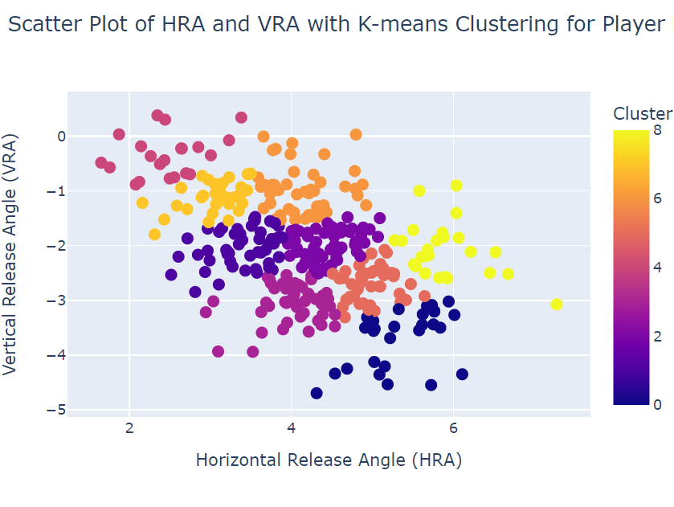

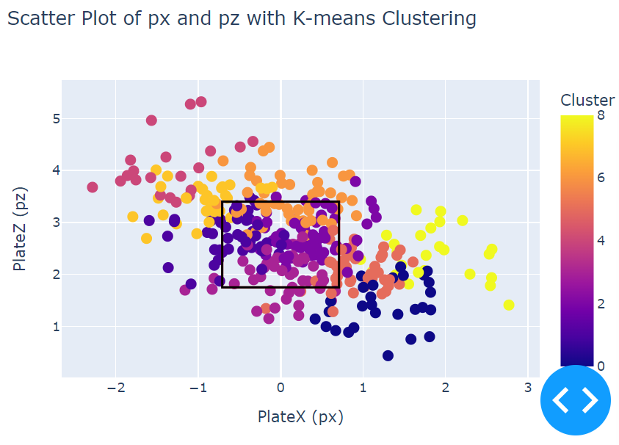

[Bad High Armside Miss](https://sporty-clips.mlb.com/T1FOWkdfV0ZRVkV3dEdEUT09X1ZRVUFWRkFHVlFFQUR3WlRWUUFBVjFRQUFGbFdBRk1BQlFjRVVsWU5Cd1ZRQWxGVw==.mp4) Top Left Red

[Top of Zone Armside](https://sporty-clips.mlb.com/0a2149db-e6b0-4ce9-b4d6-d589da92cbee.mp4) Top Left Light Orange

[Armside Middle](https://sporty-clips.mlb.com/T1FOWkdfV0ZRVkV3dEdEUT09X0J3aFhVbDBEWGxjQVcxSUhBd0FBQXdNRkFBTU5XbGtBQjF3SEFRWUNBZ2RYQndGUw==.mp4) Left Dark Purple

[In-Line Bottom of Zone](https://sporty-clips.mlb.com/d97b6a18-1da9-4f18-a67e-481413a7dfc3.mp4) Bottom Light Purple

[In-Line Top of Zone](https://sporty-clips.mlb.com/T1FOWkdfV0ZRVkV3dEdEUT09X1V3TlpBRndIQlZFQUR3Y0hCQUFBVlFFRkFBTlFVVmdBQzFNRlVsWUFWMUpVQUFzRA==.mp4) Middle-top Dark Orange

[Gloveside/Middle Middle of Zone](https://sporty-clips.mlb.com/T1FOWkdfV0ZRVkV3dEdEUT09X0FsUlVWZ0ZWVXdBQVhRTldWZ0FBQ0FaVEFBQUZXbE1BQUFFQlVWRUZCbElFQ1FJRQ==.mp4) Middle Purple

[Gloveside Low](https://sporty-clips.mlb.com/WVFaTWdfV0ZRVkV3dEdEUT09X0FsVURWRmRXVVFFQUFGQlFCd0FBQkZkUkFBTU1CUU1BVUZjSFZsRUhWd1ZRVWdwUQ==.mp4) Lower Right Red

[Gloveside High Misses](https://sporty-clips.mlb.com/T1FOWkdfV0ZRVkV3dEdEUT09X0JGTUZVQWNNWGdjQURWdFhWUUFBVjFkZkFBTUNVbEFBVTExVEFnTlhVZ3BXQUZSZQ==.mp4) Far Right Yellow

[Gloveside Spiked Miss](https://sporty-clips.mlb.com/5ed8c4e9-8c3f-48b0-8c0d-6fef510414a2.mp4) Bottom Right Navy Blue

2023 Clusters

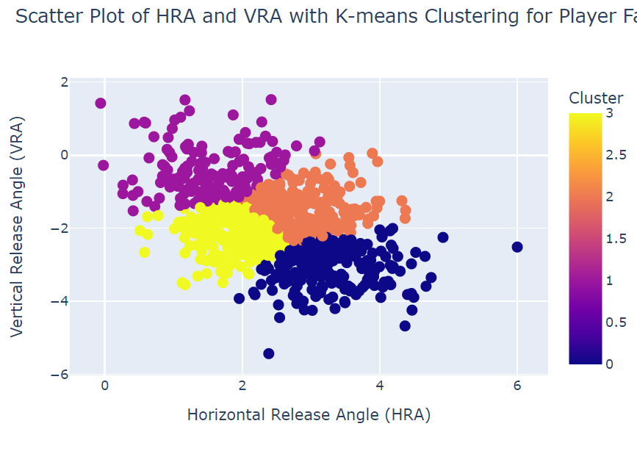

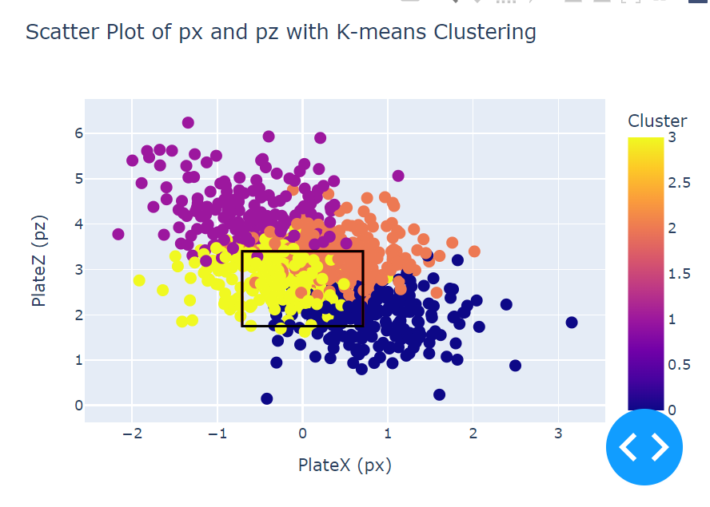

[High Armside Miss](https://sporty-clips.mlb.com/1c4b8517-0d68-4870-933c-9ebeb27c77c9.mp4) Top Left Purple

[Armside in zone](https://sporty-clips.mlb.com/85ab5b1d-cf08-4507-9eea-30d262891295.mp4) Middle Yellow

[Gloveside Top Half of the zone](https://sporty-clips.mlb.com/1377f6bf-f8d8-4c05-b718-4c84075fe3c7.mp4) Middle Orange

[Gloveside Low](https://sporty-clips.mlb.com/05a5977f-2ab4-4d34-9fd0-a232976c6b51.mp4) Bottom Right Navy Blue

Blaze Pontes

| Year | Kirby | VRA% | HRA% | ReleaseX% | ReleaseZ% | InZone | #Clusters |
| --- | --- | --- | --- | --- | --- | --- | --- |
| 2023 | .470 | .305 | .525 | .661 | .627 | .444 | 9 |
| 2024 | .472 | .375 | .828 | .391 | .219 | .471 | 8 |

Looks like there has been some improvement especially with his horizontal release score and keeping pitches in line with the plate. As you can see in the clustering below, in 2023 most of his release angles were from 1 - 3 degrees with a few pitches outside that range. In 2024, that range shifted from 1.5 - 3.5 degrees with fewer outside that. Even within the 1.5-3.5 range the tightness between 2 and 3 degrees of the clusters is quite impressive demonstrating a real improvement of keeping more pitches in line with the plate. This has resulted in a 3% increase in his zone rate on the four seam. There were a lot more armside misses in 2023 compared to 2024. Looking at his overall pitch usage, he has increased his sinker usage significantly so he is probably looking to utilize that pitch more on that side of the plate.

2023 Clusters

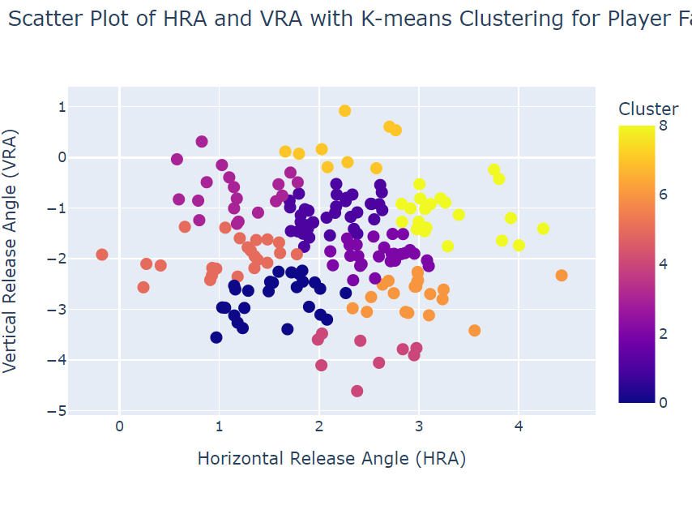

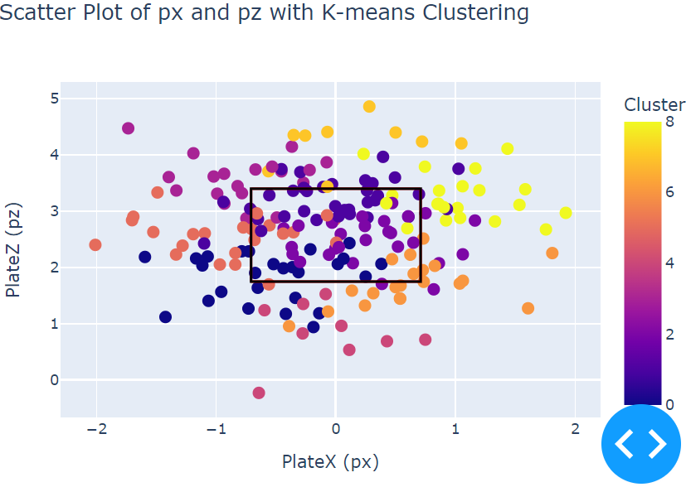

[High Armside Miss](https://sporty-clips.mlb.com/d0c9d73c-102f-4539-8acf-462825e04fb6.mp4) Top Left Light Purple

[Armside Middle](https://sporty-clips.mlb.com/d2b4edf0-05ce-425c-ae4e-25d97e923dfd.mp4) Left Red

[Armside Low](https://sporty-clips.mlb.com/8e9033ef-f6bc-495c-8a3a-ff1be4d9b45f.mp4) Lower Left Navy Blue

[In-Line Above the Zone](https://sporty-clips.mlb.com/63a796cb-1216-4247-aa7f-f1b4d2f2003c.mp4) Top Light Orange

[Top of Zone Middle](https://sporty-clips.mlb.com/4861e6bc-82d6-4e4d-aed6-5d66b4bc2313.mp4) Middle-Top Dark Purple

[Middle Middle](https://sporty-clips.mlb.com/cd74881d-4c7a-448a-98ab-2444b1131ec7.mp4) Middle Lighter Purple

[In-Line Below the Zone](https://sporty-clips.mlb.com/bb5ecb05-ca97-4420-ac32-99f5f6e24417.mp4) Bottom Red

[Gloveside Low](https://sporty-clips.mlb.com/6f80e44d-f205-4b1a-a1f6-04056e157ce9.mp4) Lower Right Orange

[Gloveside High](https://sporty-clips.mlb.com/fe598e25-1782-4e53-a9cf-454498329323.mp4) Right Yellow

2024 Clusters

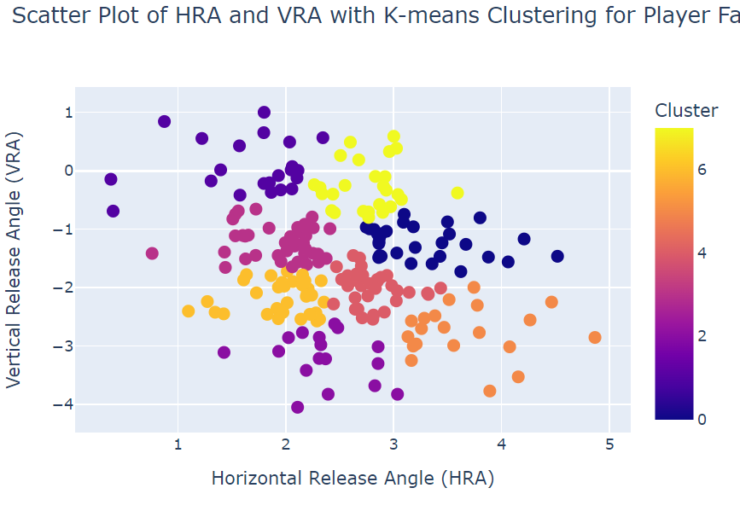

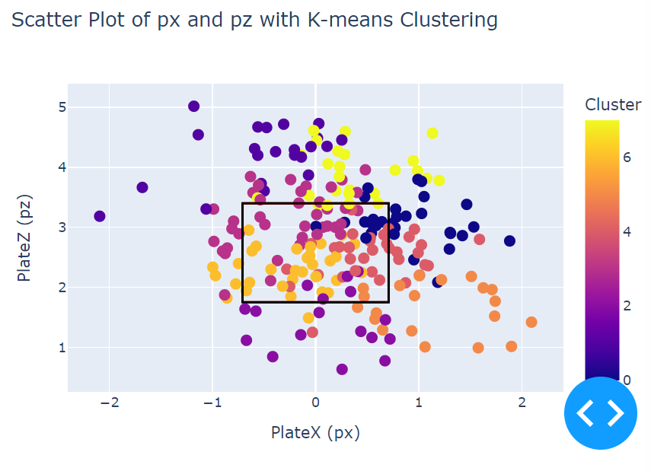

[High Armside](https://sporty-clips.mlb.com/UGpXMGRfV0ZRVkV3dEdEUT09X1ZWUllBVllEWGxRQURBUUZCQUFBQ0FKVUFGaFVCVlVBQXdNTlVsRlFCVlpXVXdwZQ==.mp4) Top Left Dark Purple

[High In-Line](https://sporty-clips.mlb.com/9bd2e25f-d217-482a-916d-af0c239572e8.mp4) Middle Yellow

[In Zone Top Half](https://sporty-clips.mlb.com/WmVkTzhfV0ZRVkV3dEdEUT09X1ZBQlRWd1VEQlFFQVd3WUJVd0FBVlZVRkFGaFFCUUlBVmwxUUF3QU1BZ3BXVmdRSA==.mp4) Middle Light Purple

[Bottom Half In Zone](https://sporty-clips.mlb.com/798e2309-799c-4835-a7e0-79d2f0aa5294.mp4) Middle Light Orange

[In Line Below the Zone](https://sporty-clips.mlb.com/UGpXMGRfV0ZRVkV3dEdEUT09X0FBa0VWd2NHVWdJQUFRQUFYd0FBVndjRkFBTlJCVmdBQjFFSEF3VUFDRkJWQWd0WA==.mp4) Middle Purple

[Gloveside High](https://sporty-clips.mlb.com/bca84257-c62b-4dee-bd30-b482a49f394f.mp4) Top Right Navy Blue

[Gloveside Middle](https://sporty-clips.mlb.com/NU5Mak5fV0ZRVkV3dEdEUT09X1VBVlVVbFlFQUZjQURGVlhVUUFBVUFJRkFBQlFVRllBQXdSUlVnSUFCRlZXQUZkUw==.mp4) Middle Right Red

[Gloveside Low](https://sporty-clips.mlb.com/d31e4f5c-22e7-4de1-b564-be507b2193c2.mp4) Bottom Right Orange